**# School_District_Analysis – using Pandas and Data Frame**

Using Pandas Library this exercise :

We need to upload the two CSV files in this exercise before we do the following deliverable:

1. Schools_complete.csv - this one represents the school budget by school
2. Students_complate.csv – this one represents the school grades by school

**Deliverable 1: Replace the reading and math scores.**

**Replace the 9th grade reading and math scores at Thomas High School with NaN**

We need to use Pandas “loc” method and NumPy module to relance all 9th graders reading and math score. These will eliminate the read and math scores for Thomas High School from overall scores.

Using the following code that show the out puts of the Data Frame:

* Student_data_df.trail(10) that show the output in the Jupyter Notebooks.

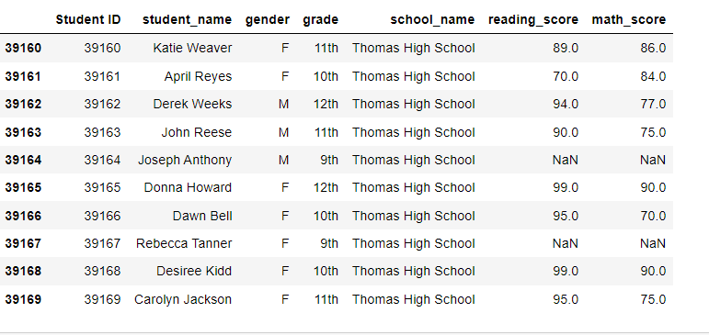

**Deliverable 2 : Repeat the school district analysis**

* The district summary
* The school summary
* The top 5 and bottom 5 performing schools, based on the overall passing rate
* The average math score for each grade level from each school
* The average reading score for each grade level from each school
* The scores by school spending per student, by school size, and by school type

The district Summary:

There are 15 different school represent this school district Summary with different type of schools.

In this exercise we can find different result with average reading and math scores and passing percentage both subjects. It also shows the overall Passing percentage for all 15 Schools and Total Budget.

